* **Activity 2:**

Using the UNION ALL Operator

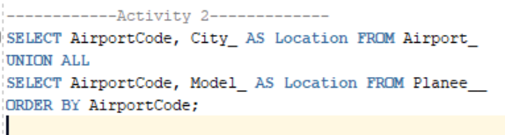

OUTPUT:

